The command prompt for the server.

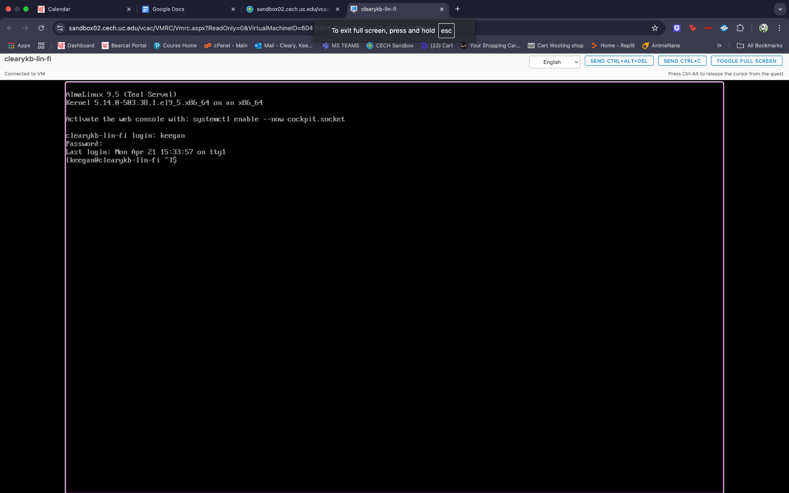

The /etc/passwd file showing user accounts for the Web Dev team.

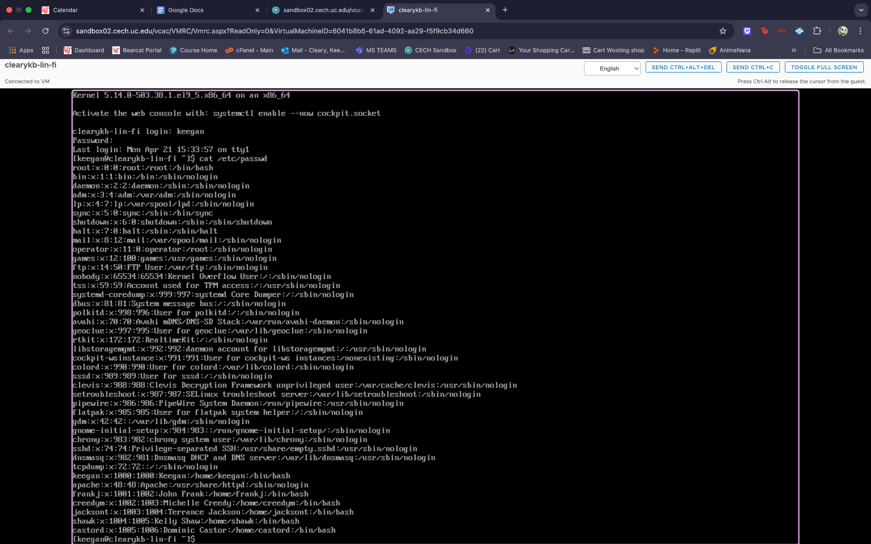

The /etc/group file containing a group for the Web Dev team with user accounts.

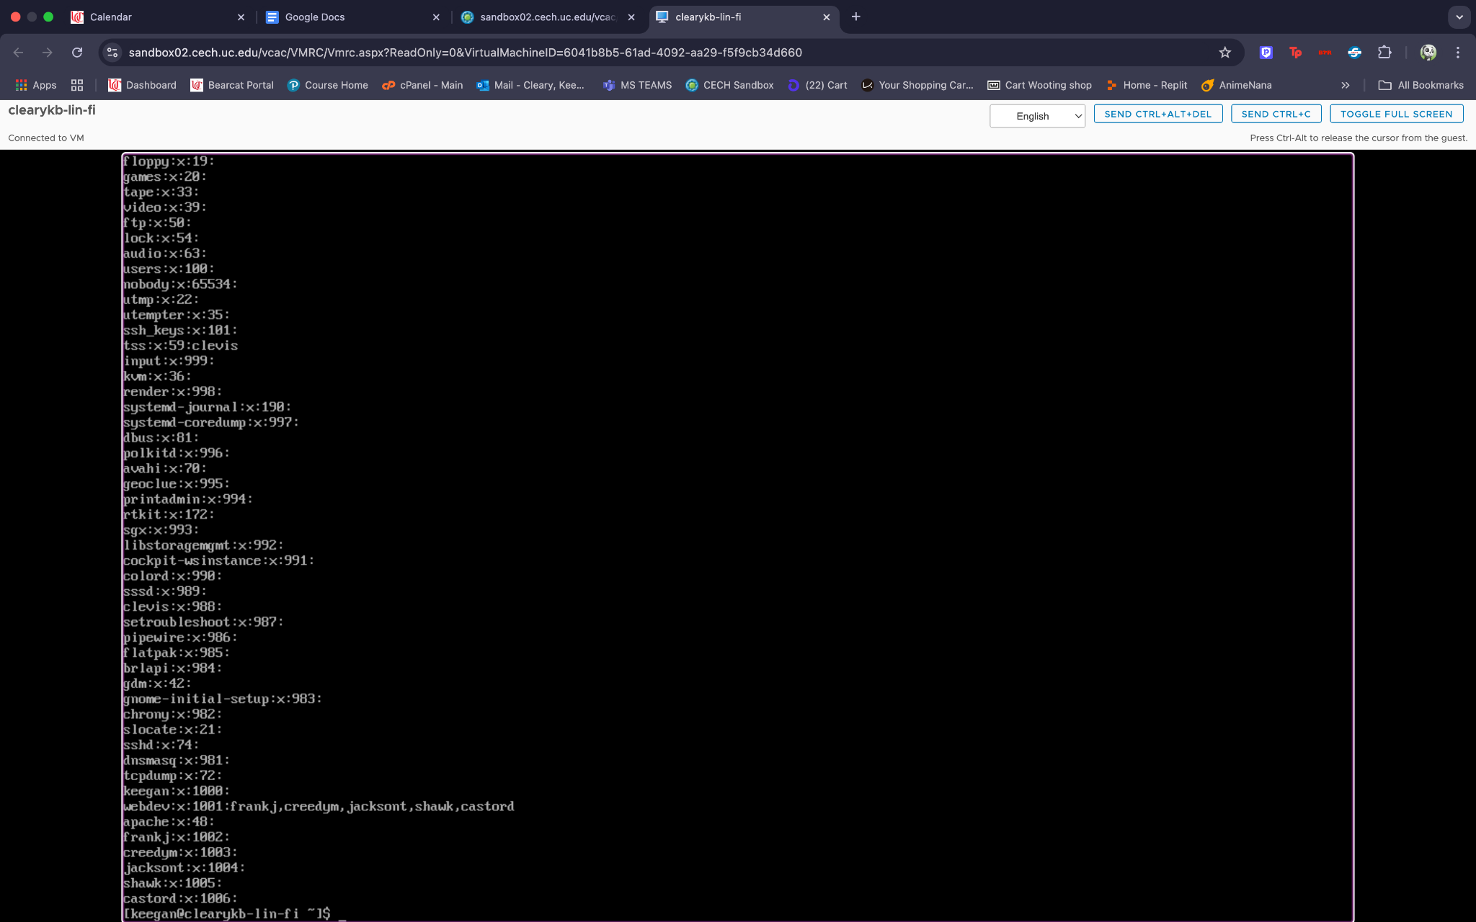

The /etc/group file containing a group for the Web Dev team with user accounts.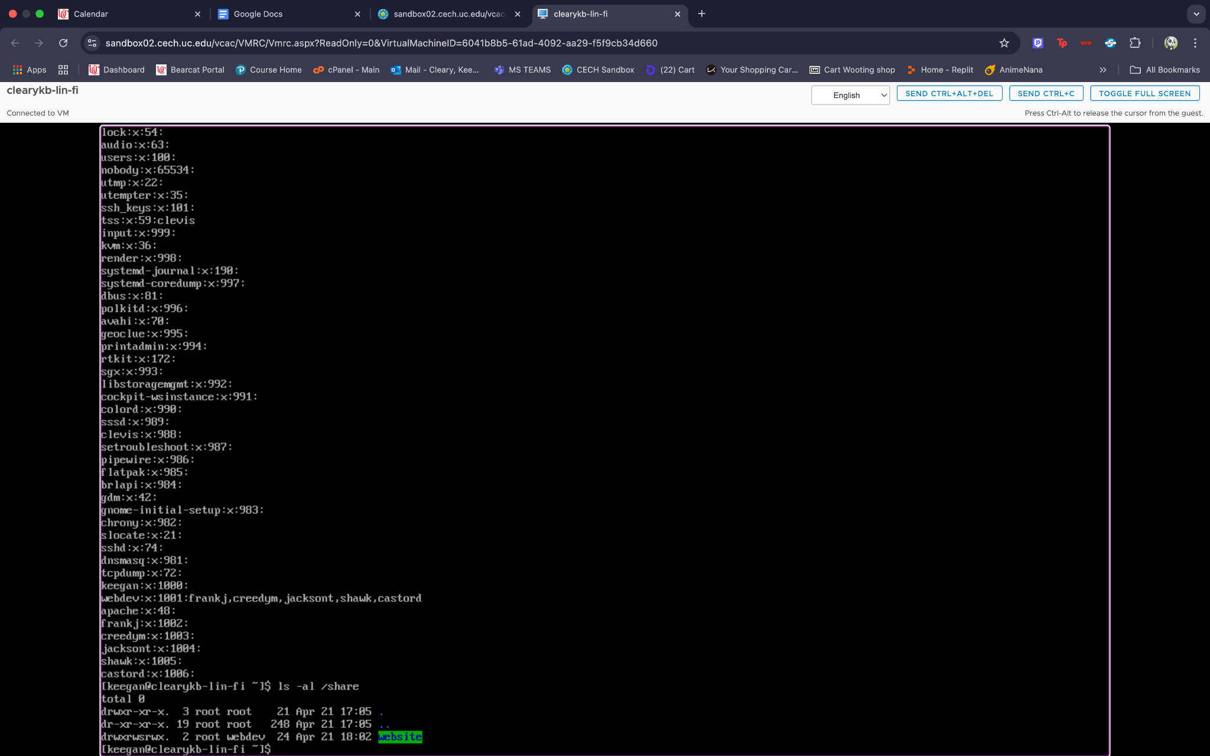The settings for the shared directory in the samba configuration file.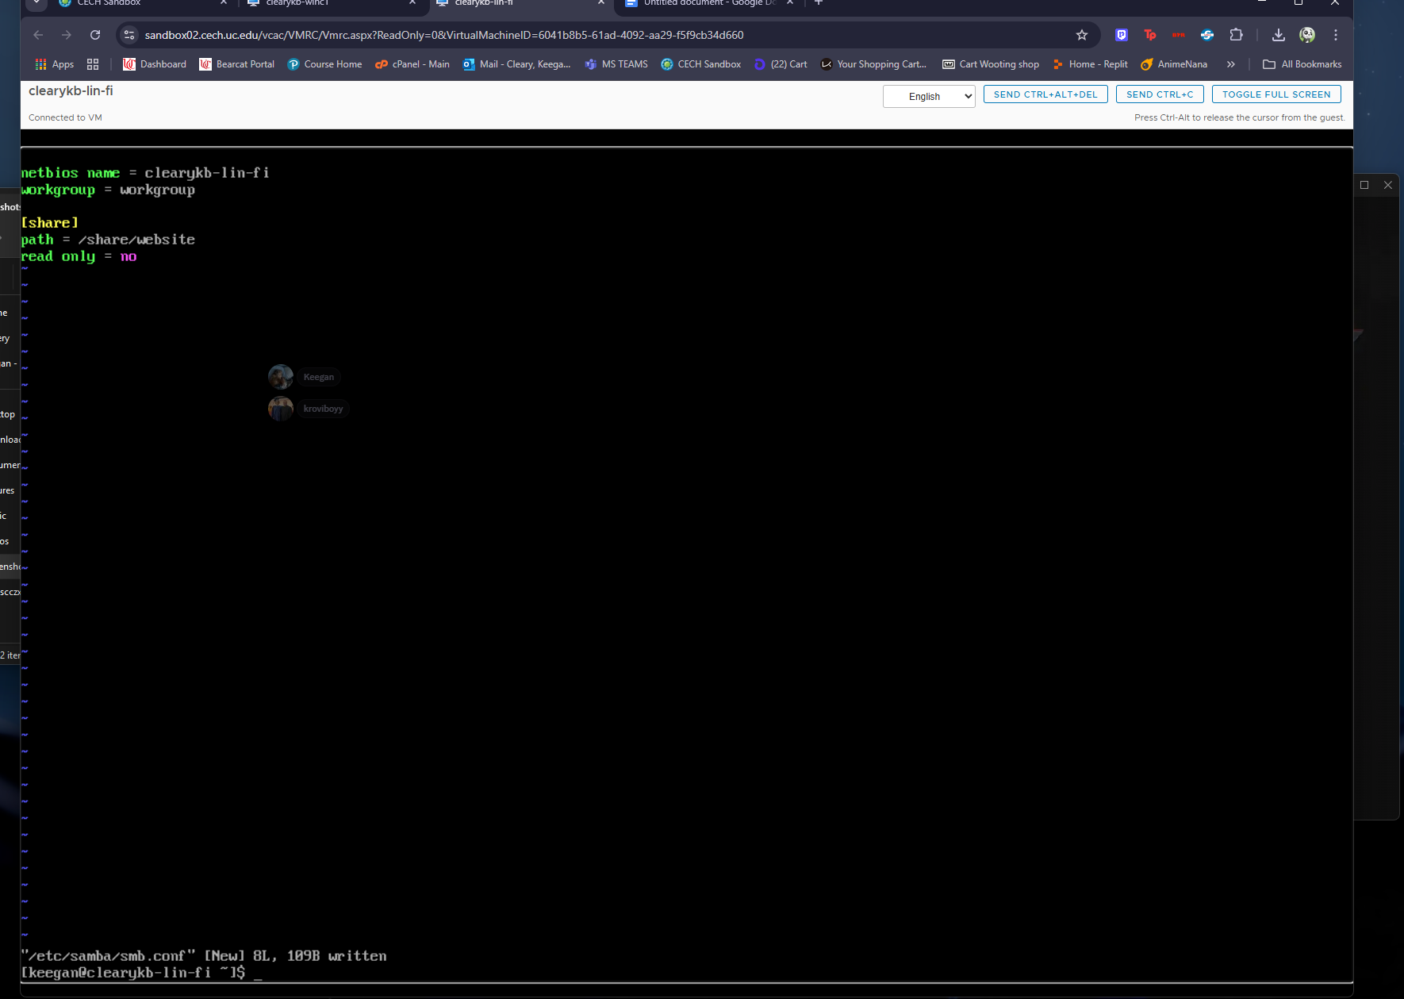The settings for the Document Root directory in the Apache configuration file.

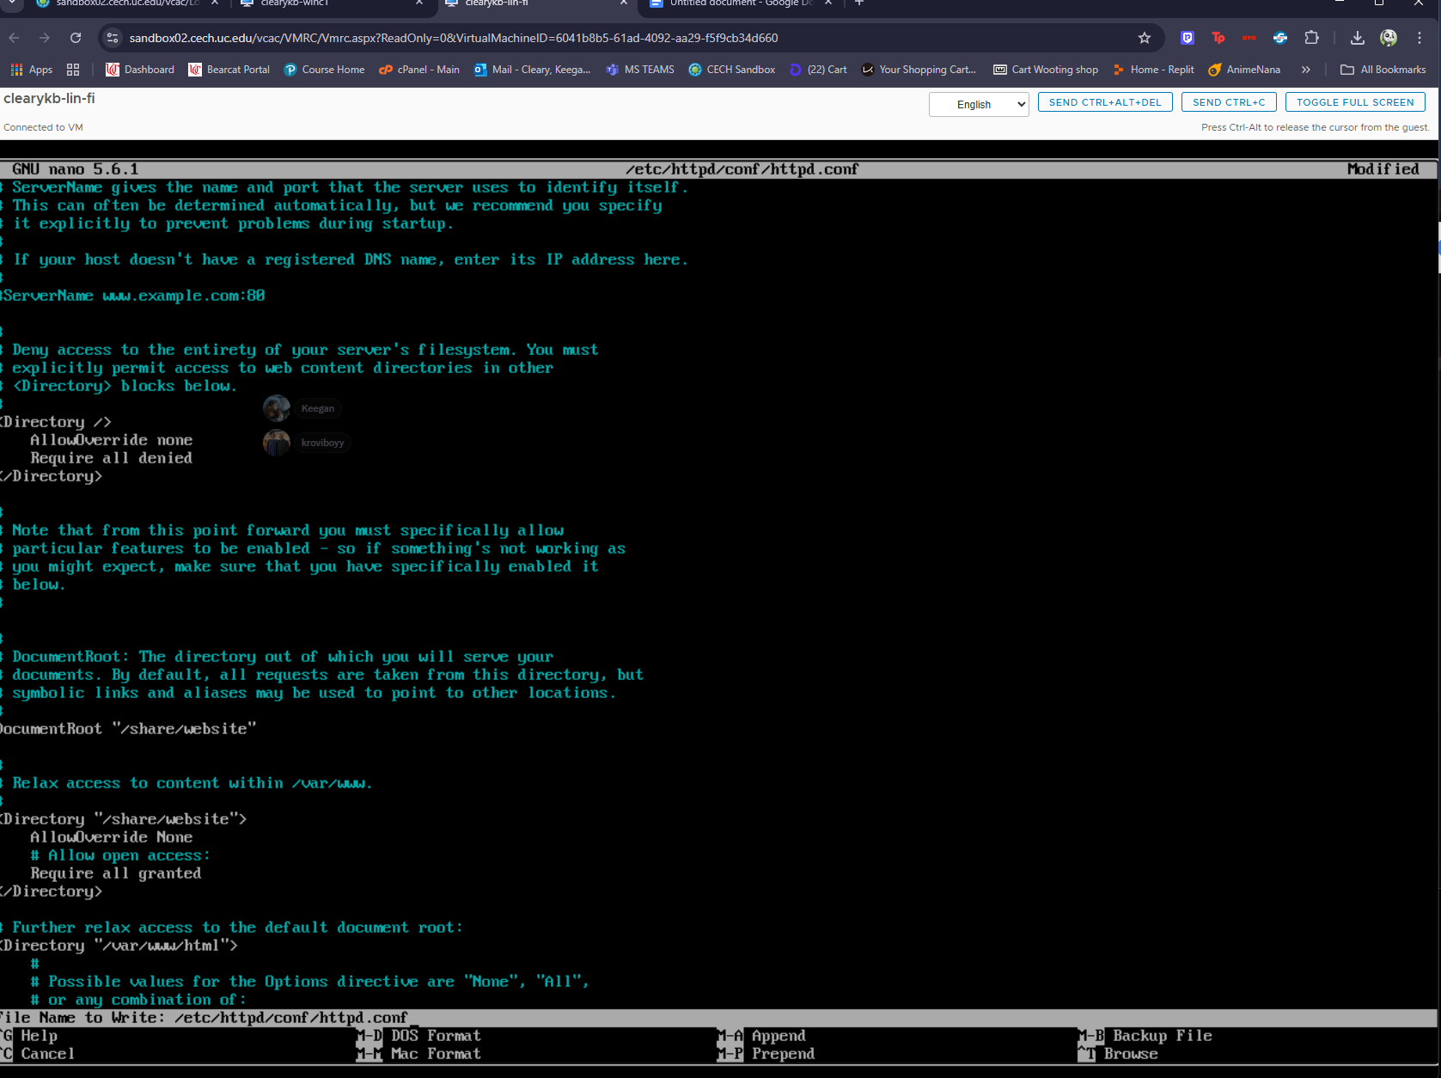

Allowed services through the system firewall.

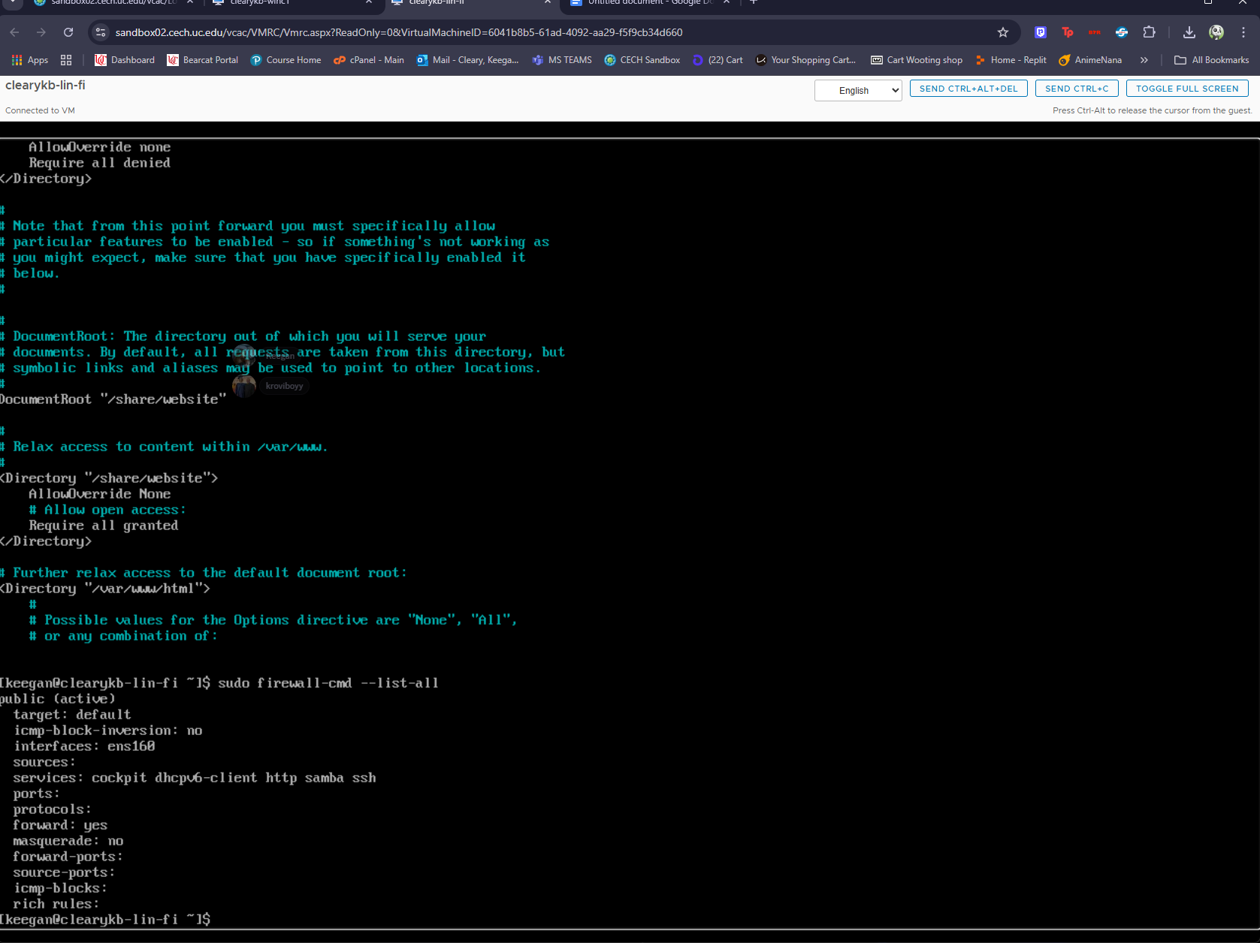

Connecting to the system from a Windows 11 workstation through SSH as one of the 5 users you created and running a command as sudo.

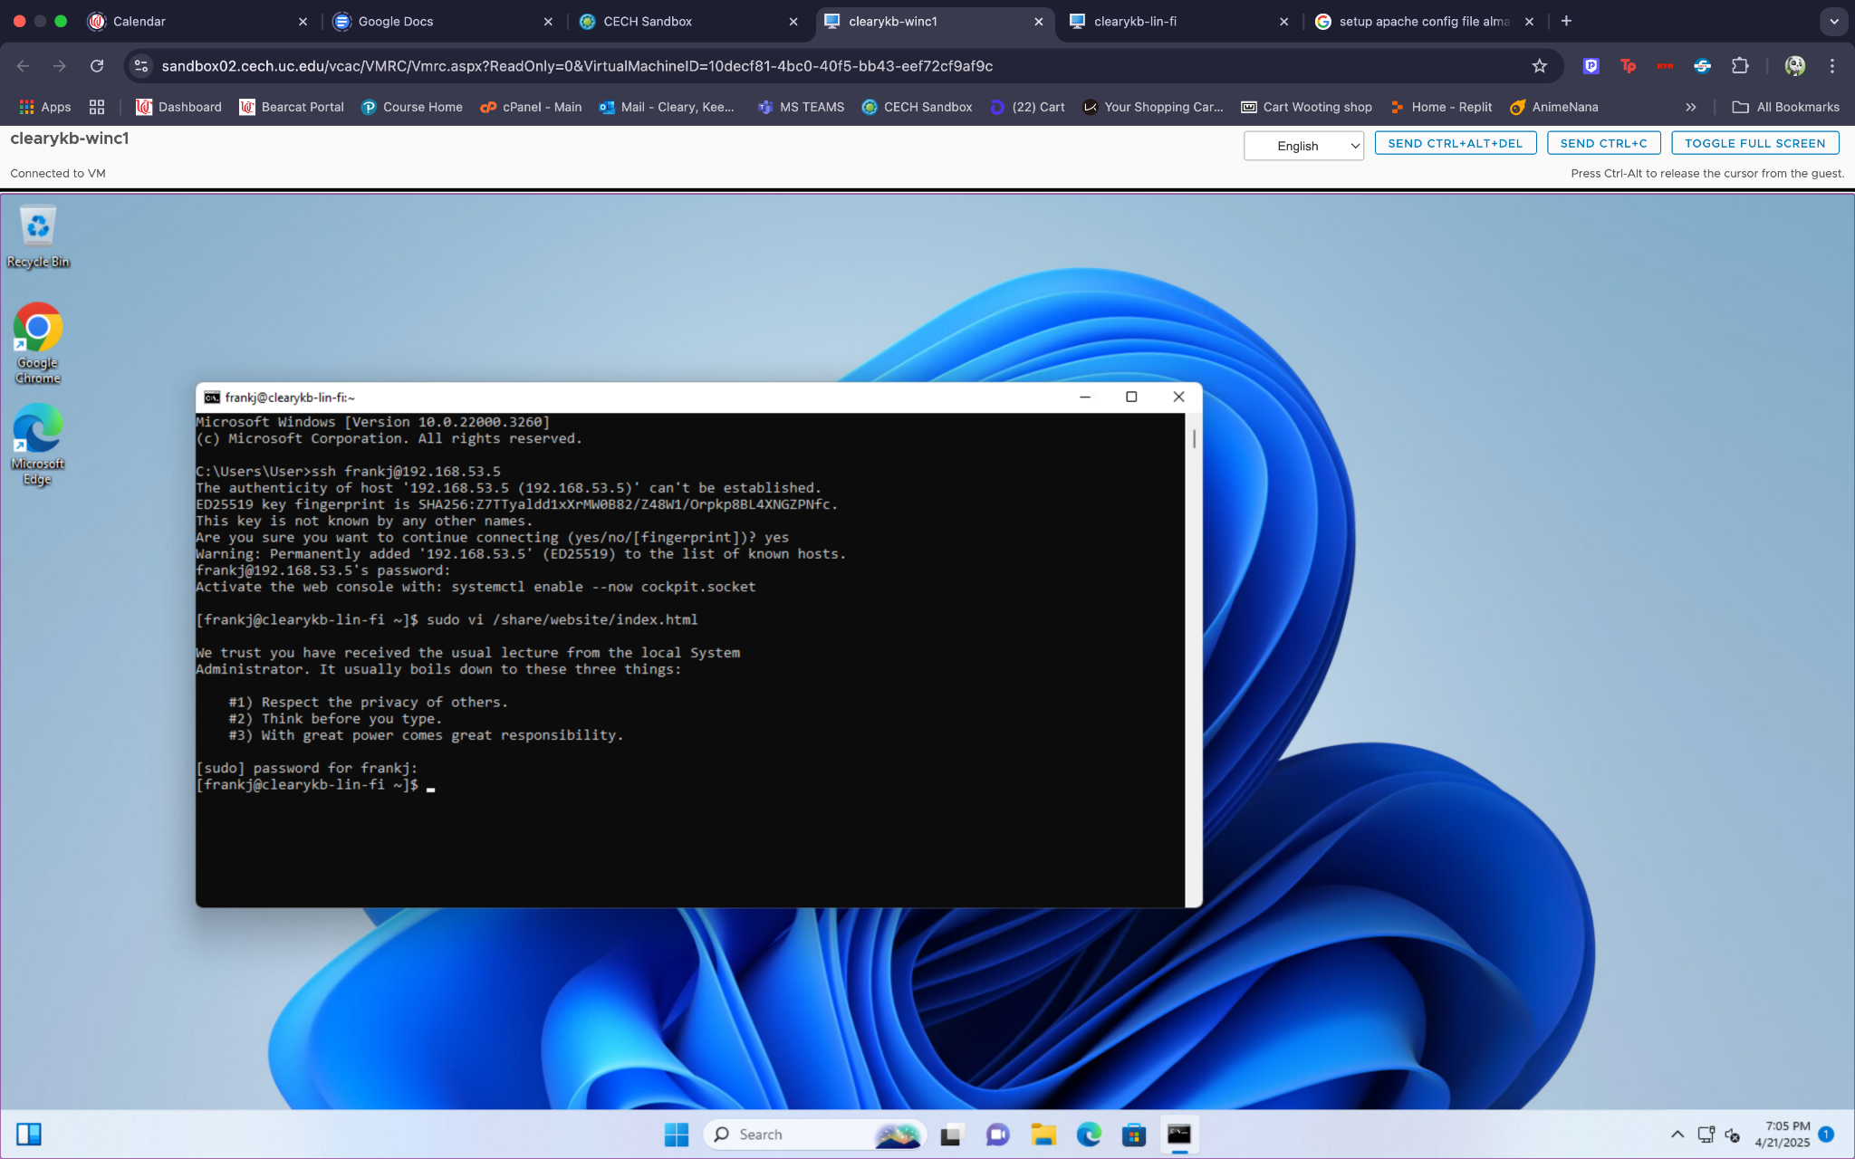

Connecting to the system from a Windows 11 workstation to access the shared directory through Windows File Explorer.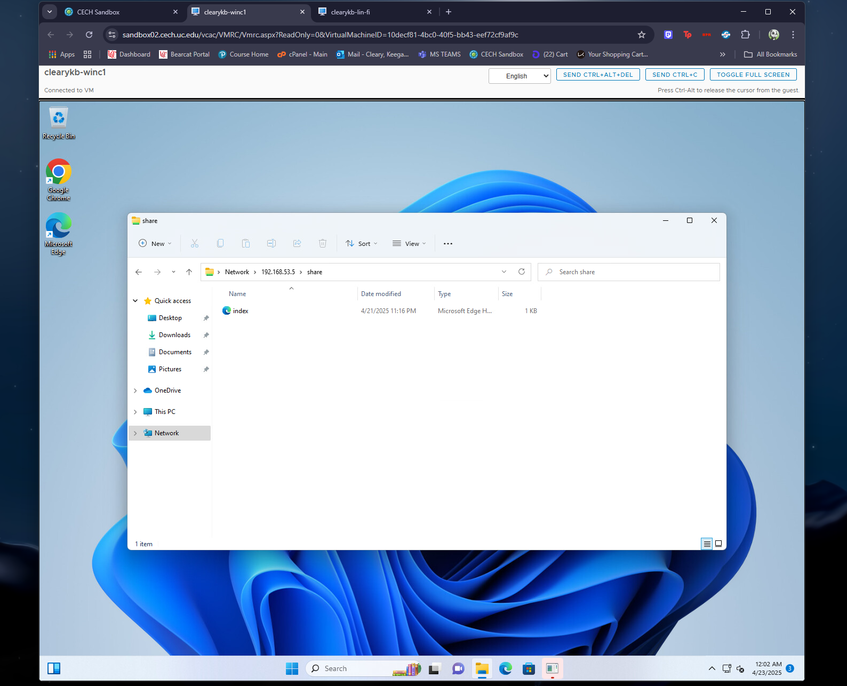

Connecting to the system from a Windows 11 workstation through a web browser using http.

